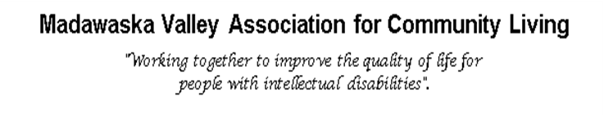

Community Participation Support Student

Job type: Part Time

Duration: On or about July 2 until August 31, 2025

Hours: 35 hours per week

Salary: $17.20 per hour

Location: Community Connect and within the larger Community of Barry’s Bay Ontario

About You
You are a creative and driven person with a passion for working with people. You have excellent communication skills and are resourceful, organized and consider yourself a self-starter. You thrive in a team-based environment that is constantly evolving and offers a variety of day-to-day tasks and responsibilities. You are determined to deliver results despite challenges you may incur. Through your work and contributions your goal is to make an impact on the community.
As the ideal candidate, you are friendly and enjoy engaging with others. You have strong writing skills and an ability to help others with theirs. You are computer literate in a variety of programs, including Word, Publisher, Excel, and various social media platforms. You can manage data effectively.
Overview
The purpose of the Community Participation Support Student (CPSS) position is to assist with increasing community connections through outreach, awareness and education. Through sourcing and sharing accessible information on topics such as inclusion, developmental disabilities, developmental services work, as well as highlighting other social justice alliances. The focus will be to improve awareness of our main goal, which is inclusion and belonging for all people in our community.
In addition, the CPSS will have a unique opportunity to discover what working in the Developmental Service sector really looks like. While the employee will provide a valuable service to our agency and those we serve, they will also be acquiring knowledge and skills that will impact their career.

Additional Information
MVACL is committed to providing accommodations for people with disabilities. If you require an accommodation, we will work with you to meet your needs.
To apply, please send a resume and cover letter via email, mail or fax.

Jaclyn Read, Human Resources Coordinator
Madawaska Valley Association for Community Living
19491 Opeongo Line, Box 1178, Barry's Bay, Ontario, K0J 1B0
Fax: 613-756-0616 Email: hr@mvacl.ca
Website: www.mvacl.ca
We would like to thank all candidates who apply, but only those chosen for an interview will be contacted.

Closing date: June 13,2025 at 4:00pm
Positions available: 1

