

Madawaska Valley

Association For

Community Living

**POLICY: ETHICS ADVISORY COMMITTEE**

**PAGES: 14**

**REVISED:**

**REVIEWED: JULY 7, 2022**

**APPROVED: OCTOBER 17, 2017**

**NUMBER: 5-14**

**CATEGORY: SERVICE DELIVERY** 

Policy:

The committee recognizes that many ethical dilemmas arise in the support environment. Many will be resolved at the front line or with a focused discussion involving the person supported/family and support team. However, there may be other ethical dilemmas which would derive benefit from a formal consultation with the Madawaska Valley Joint Ethics Advisory Committee.

The MCCH Joint Ethics Advisory Committee will act solely in an advisory and consultative capacity. All patients/family members and staff will be advised of their right to access the Ethics Advisory Committee.

Requests to other appropriate supports e.g. pastoral care, Ethicist, community resource listing, may be accessed as required.

Procedure:

The Submitter:

* If unable to reach a resolution to identified ethical dilemmas following consultation with team members, person supported and family, considers the option of submitting the dilemma to the MCCH Joint Ethics Advisory Committee.
* Advises person supported and family that they also have the option to consult with the MCCH Joint Ethics Advisory Committee and provides appropriate information and assistance.
* Contacts one of the MCCH Ethics Advisory Committee representatives to initiate an informal discussion of the situation. This list can be found on the MVACL website
* Completes a *Consultation Request* (Appendix A) in collaboration with the representative if the decision is made to submit the dilemma to the Committee.
* Ensures that any urgency to the situation is clearly communicated to the Committee.
* Provides further information as requested by the Committee. Retains the option of speaking directly to the Committee.
* Receives the written *Response to Submitter* (Appendix B) from the Committee which will include recommendations and options. Asks for clarification and guidance from the Committee as required.
* Implements selected recommendation(s) in collaboration with the support team, person served and family.
* Completes an *Evaluation – MCCH Joint Ethics Committee Consultation* (Appendix E) form (optional)

The MCCH Joint Ethics Advisory Committee Representative:

* May receives a request for consultation verbally, electronically or in writing.
* Arranges to meet with submitter(s) to complete the *Consultation Request.*
* Advises Chair of submission and degree of urgency to situation
* Maintains contact with submitter(s) and gathers additional information as required per Committee request. Ensures that submitter(s) is kept informed of consultation progress.
* Provides submitter(s) with completed *Response to Submitter*
* Acts as a resource to submitter for implementation of recommendations.
* Makes access to the MCCH Joint Ethics Advisory Committee available at their represented agency.

The MCCH Joint Ethics Advisory Committee Chair:

* Calls Committee meeting(s) in response to consultation requests recognizing urgency of situation
* Facilitates Committee process and consultation with additional experts external to the Committee if deemed appropriate

The MCCH Joint Ethics Advisory Committee:

* Considers each consultation request following the Ethical Framework (Appendix C) using the Consultation Worksheet. (Appendix D)
* Consults with external ethicist as required
* Evaluates Committee performance on an annual basis including review of all completed *Evaluation – Ethics Committee Consultation* forms (Appendix E)

**APPENDIX A**

**Consultation Request**

**MCCH JOINT ETHICS ADVISORY COMMITTEE**

|  |  |
| --- | --- |
| **Date referral received*:*** | **Received by:** |
| **Site/Unit/Program/Organization:** | **Method of referral:** |
|  | |
| **Referring person:** | **Phone number:** |
| **Date referral contacted:** | |
| **Name of patient/Client:** | **Role/relationship of**  **referring person:** |

**To be completed by the Referral Facilitator with the Referring Person.**

1. Brief description of the issue.
2. Reason for the request
3. Review of the parties involved in the situation
4. Background information.
5. Alternatives already explored and the outcomes.
6. Urgency.
7. Would an ethics consultation help?
8. Who from the patient’s family and/or treatment team should be involved?
9. Does the referring person have views on the type of consultation (large/small), professionals (ethics, lawyers, spiritual care, physicians)?
10. Preferred location and time of consult or alternative preferences.
11. Expectation of the ethics consultation.

**The purpose of an ethics consultation is to clearly identify courses of action and analyze the ethical implications of each. It is not the task of the consultation team to make a decision (like a court of law) or to recommend a clear course of action (like a medical consult).**

**All requests for ethical consultation are subject to the confidentiality of member organizations. All resulting discussion and outcomes will be subject to applicable confidentiality laws and legislation.**

**I ______________________agree with the statement of the problem and understand the role of ethics consultation.**

______________________________ ___________________ Signature of Referring PersonDate

______________________________ ___________________

Signature of Referral Facilitator Date

|  |  |
| --- | --- |
| **Is a formal consultation proceeding?** | |
| **YES: Date/place/time** | **NO: Reason** |

**APPENDIX B**

**RESPONSE TO SUBMITTER**

**MCCH JOINT ETHICS ADVISORY COMMITTEE**

|  |  |
| --- | --- |
| **Date referral received*:*** | **Received by:** |
| **Site/Unit/Program/Organization:** | **Method of referral:** |
| **Referring person:** | **Phone number:** |
| **Name of patient/Client:** | **Role/relationship of**  **referring person:** |

**Summary Ethical Dilemma**

**Primary Considerations/Impacting Factors**

**Options Considered & Rationale**

**Recommendation(s)**

**Additional Comments**

______________________________ ___________________ Signature of Chair Date

MCCH Joint Ethics Advisory Committee

**APPENDIX C**

**MCCH JOINT ETHICAL COMMITTEE**

**DECISION-MAKING FRAMEWORK**

Ethics is about making “right” or “good” choices and the reasons that we give for our choices and actions. Ethics promotes reflective practice in the delivery of health care. Ethics addresses the question “What should we do and why?”

Another way to describe ethics is as follows. It is about:

* Deciding what we should do – what decisions are morally right or acceptable;
* Explaining why we should do it – justifying our decision using language of values and principles; and
* Describing how we should do it – outlining an appropriate process for enacting the decision.2

Ethical issues arise every day in health care (See Appendix A). Everyone has a role to play in ensuring the ethical delivery of care, from bedside to boardroom. St Francis Memorial Hospital is committed to providing quality compassionate care to the community it serves. Ethical principles and values are incorporated into the way that decisions are made and care is delivered every day. Accreditation Canada expects that healthcare organizations will have in place a framework for guiding ethical behavior that is publicly accessible and consistent with the law.

As healthcare organizations seek to provide quality care in the face of significant financial constraints, they face difficult decisions. Both technical (e.g., cost-effectiveness analyses) and principle-based solutions (e.g., distributive justice) alone are limited in their ability to resolve priority-setting challenges (Gibson, Martin, & Singer, 2005). Given that there may be competing goals and values, ensuring procedural fairness may be the best way to ensure that decisions are socially accepted and demonstrate public accountability (Gibson et al., 2005).

The purpose of the IDEA: Ethical Decision-Making Framework (see Figure 2) is to provide a step-by-step, fair process to help guide healthcare providers and administrators in working through ethical issues encountered in the delivery of healthcare. The Framework can be used to guide decision-making and actions about ethical issues that arise from the bedside to the boardroom. The framework addresses two general types of ethical decisions that lie across a continuum: clinical and organizational.

Clinical ethical decisions are typically those that involve and impact specific patients or staff members and focus on individual values (e.g., Should Mr. B’s life-sustaining treatment be discontinued?). Organizational ethical decisions are generally those that involve and impact groups of patients or staff members, units, systems, or the organization as a whole and centre on the values of the organization (e.g., Should the program be expanded, reduced, or remain unchanged?). Some ethical decisions may be predominantly clinical in nature; others will be largely organizationally focused. A number of ethical decisions will have both clinical and organizational aspects.

Use of the frameworks can help an individual, team or community to work through an ethical issue. It can help a team or community work together by introducing a shared systematic process, facilitating effective communication, developing a shared language and building a common understanding of how to approach difficult ethical issues.

When organizational decisions are being made in relation to ethics, the Accountability for Reasonableness Framework may be used as a guide for decision-making (see Figure 1).

2 Definition adapted from Dr. Barbara Secker, Joint Centre for Bioethics, University of Toronto.

**IDEA1:**

Ethical Decision-Making Framework

COMPLIANCE

* 1. **Act.**
     + Recommend
     + Implement
     + Evaluate

Ask: *Are we (am I) comfortable with this decision?*

What is an ethical issue?

* *Am I trying to determine the right course of action?*
* *Am I asking a “should” question?*
* *Are values and beliefs involved?*
* *Am I feeling uncomfortable?*

1. **Identify** the Facts.
   * Medical Indications
   * Patient Preferences
   * Evidence
   * Contextual Features

Ask: *What is the ethical issue?*

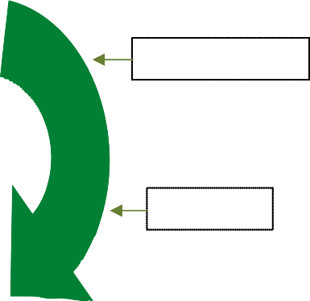

EMPOWERMENT

PUBLICITY

If you answered yes to any of these questions, you may be encountering an ethical issue.

1



REVISIONS & APPEALS

1. **Explore** the Options.
   * Harms & Benefits
   * Strengths & Limitations
   * Laws & Policies
   * Mission, Vision, Values

*Ask: What is the most ethically justifiable option?*

RELEVANCE

2**. Determine** the Relevant Ethical Principles.

1 The IDEA: Ethical Decision-Making Framework builds upon the Toronto Central Community Care Access Centre *Community Ethics Toolkit* (2008), which was based on the work of Jonsen, Seigler, & Winslade (2002); the work of the Core Curriculum Working Group at the University of Toronto Joint Centre for Bioethics; and incorporates aspects of the accountability for reasonableness framework developed by Daniels and Sabin (2002) and adapted by Gibson, Martin, & Singer (2005).

* + Nature & Scope
  + Relative Weights

Ask: *Have perspectives of relevant individuals been sough*

Guideline for the use of the Accountability for Reasonableness (A4R) Framework for Organizational Ethics Issues

**The Accountability for Reasonableness Framework (A4R)1**

*An ethical decision-making framework has also been accepted for organizational decision-making. The Accountability for Reasonableness Framework (A4R) is based on the notion of public accountability which requires that reasons and rationales for limit-setting decisions be publically available. The goal of this framework is to ensure that a fair process is available for stakeholders to follow, and expectations are set to consider relevant values in the justification of organizational decisions.*

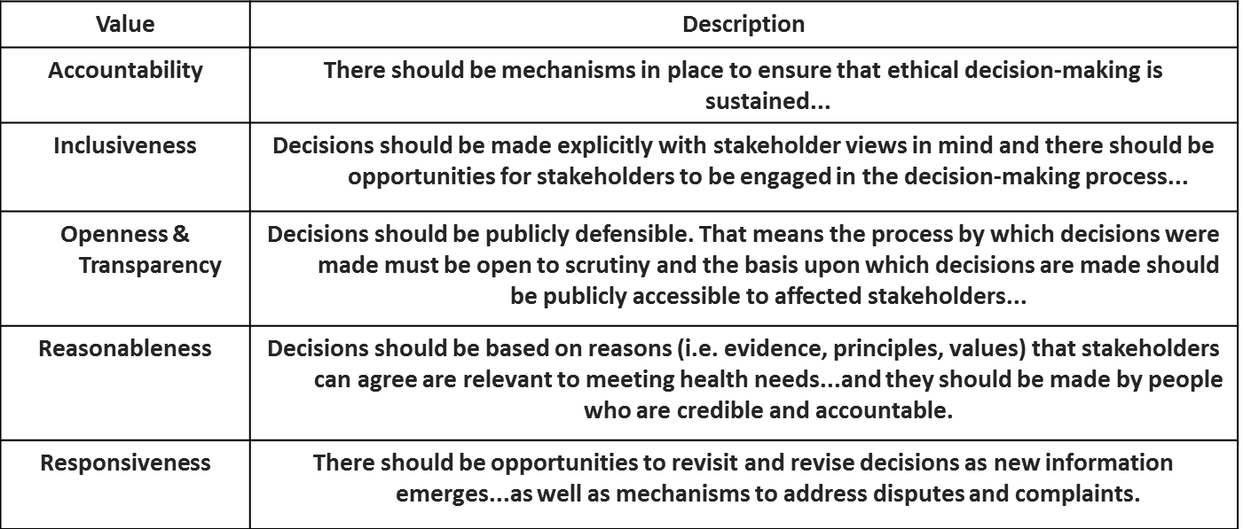

**Appendix D**

**Ethics Worksheet – IDEA Framework**

**Date:**

|  |
| --- |
| **Step 1: Identify the Facts.** |
| *What is the presenting ethical issue(s)?* |
| *What are the relevant medical or other indications?* |
| *What are the patient(s) preferences? (if applicable)* |
| *What is the evidence?* |
| *What are the contextual features?* |
| What is the ethical issue? |
|  |

|  |  |  |
| --- | --- | --- |
| **Step 2: Determine the Relevant Ethical Principles.** | | |
| *Who are the stakeholders (relevant parties)?* | *What values/principles does each believe are relevant to the issue?* | *Which values/principles do stakeholders agree are most important in the current context? (Rate from 1 to ….)* |
| *Are there any other factors that need to be considered?* | | |
| Have perspectives of relevant individuals been sought? | | |
|  |  |  |

|  |  |  |  |  |  |
| --- | --- | --- | --- | --- | --- |
| **Step 3: Explore the Options.** | | | | | |
| *Option 1:* | | *Option 2:* | | *Option 3:* | |
| * Consistent with laws and policies * Consistent with mission, vision, values, and strategic directions | | * Consistent with laws and policies * Consistent with mission, vision, values, and strategic directions | | * Consistent with laws and policies * Consistent with mission, vision, values, strategic directions | |
| *Benefits/Strengths:* | | *Benefits/Strengths:* | | *Benefits/Strengths:* | |
| *Harms/Limitations:* | | *Harms/Limitations:* | | *Harms/Limitations:* | |
| *Meets Decision-Making Criteria (list)* | | *Meets Decision-Making Criteria (list)* | | *Meets Decision-Making Criteria (list)* | |
|  | o Yes o No o Yes o No o Yes o No o Yes o No o Yes o No o Yes o No o Yes o No o Yes o No o Yes o No o Yes o No |  | o Yes o No o Yes o No o Yes o No o Yes o No o Yes o No o Yes o No o Yes o No o Yes o No o Yes o No o Yes o No |  | o Yes o No o Yes o No o Yes o No o Yes o No o Yes o No o Yes o No o Yes o No o Yes o No o Yes o No o Yes o No |
| *Additional Resources Used (list):* | | *Additional Resources Used (list):* | | *Additional Resources Used (list):* | |
| What is the most ethically justifiable option? | | | | | |
|  | | | | | |
|  | | | | | |

|  |  |  |
| --- | --- | --- |
| **Step 4: Act.** | | |
| *Documentation/Communication of Decision (who, what, where, how):* | | |
| *Implementation Plan:* | | |
| *Evaluation Plan:* | | |
| *Process Met Conditions* | *Evidence:* | *Reviewed by:* |
| o Relevance |  |  |
| o Publicity |  |  |
| o Revisions and Appeals |  |  |
| o Empowerment |  |  |
| *Are we (am I) comfortable with this decision?* | | |
|  | | |

**APPENDIX E**

**MCCH JOINT ETHICS ADVISORY COMMITTEE**

**CONSULTATION EVALUATION**

Name of Person making referral: _________________________________

Date of Original Referral: ________________________________________

**The Joint Ethics Advisory Committee benefits from your feedback as we refine the process of ethics consultations. Please complete the following questionnaire and return it to the undersigned member of the committee.**

1. Did you have any problems finding out how to reach us?
2. Was the consult arranged in a timely fashion?
3. Was the structure and process of the consultation appropriate?
4. Did the consult address your concerns?
5. How would you rate the consult?

❑ Excellent, ❑ Good, ❑ Fair, ❑ Unsatisfactory, ❑ Very Unsatisfactory

1. How did you hear about the Ethics Consultation Service?
2. Do you have any general feedback or advice for us?

_____________________________________________________________

Please send to:

Mailing address:

Name of Person Completing Survey: